Fire Hazard Assessment Report
Offenses to address:
- Dangling Power Extension Cords.

Refrigerators & Microwave | iMac
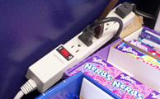 | 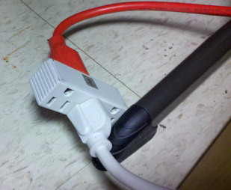
- Non-Compliant Outlet Strips. Must have surge protection.

